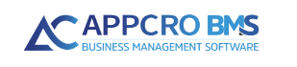

Quick start guide

Verzija 1.3

# www.appcrobms.com

content

www.appcrobms.com 1

**Getting started** 3

**1. User login** 4

**1.1. Login via user login form over the base** 4

**1.2. Login with Azure AD** 5

**2. Main control panel** 5

**2.1. User Menu** 5

**2.2. Toolbar** 6

**2.3. Sidebar (available subsystems)** 8

**2.3.1. Table overview settings** 9

**2.3.2.** **Entity profile** 9

**3. Administration - user rights and notifications** 10

**3.1. User permissions** 12

**3.1.1. Creating permission schema** 16

**3.1.2. Creating role group** 16

**3.2. User notifications** 18

**3.2.1. Creating notification schemes** 19

**3.2.2. Creating notification groups** 20

**4. Administration sidebar** 21

**4.1. Creating code books** 21

**4.2. Creating organizational units and work types (basis for user create)** 22

**4.3. Creating internal user** 23

**4.4. Dashboard Management** 23

**4.5. Email mailboxes** 23

**4.6. Outgoing mail (setting email notifications)** 26

**4.7. Scheduled jobs** 27

**4.8. Plugins** 29

# **Getting started**

Welcome to *Quick Start Guide*.

With these *Quick Start Guide* and online instructions which you'll find under the *Documentation* section of the user menu, you'll find platform easy to use. You can expect step-by-step instructions for account setup: from user login, explaining options on the main control panel, setting rights and notifications, etc.

**Once you login into the platform, under the Documentation section of the user menu you will find all system functionalities explained in the details. *(Figure 1).***

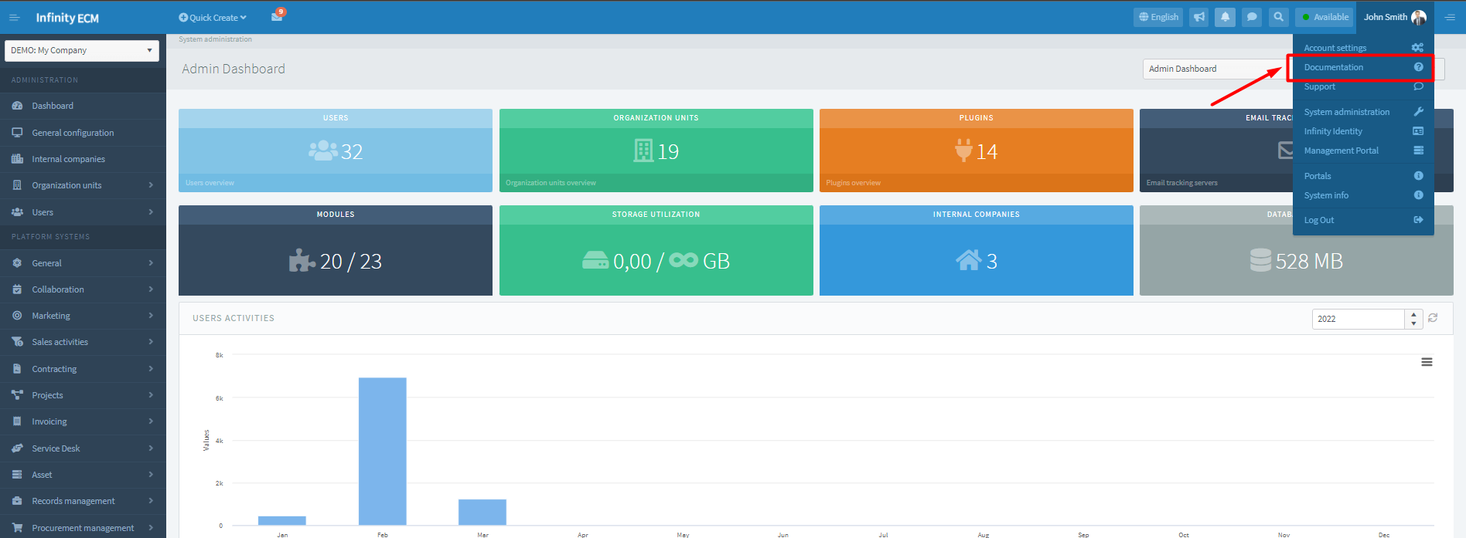

Figure 1: Dashboard – link on complete User's Guide

We’re sure you'll find platform easy to use and beneficial in terms of saving time and energy.

# **1. User login**

In order to be able to use platform, first you need to login into the system with your *username* and *password.* You can login in two ways:

1. via the user login form over the database
2. login with Azure AD (if you have 365 office account)

## **1.1. Login via user login form over the base**

For login over the base, the system administrator should create a user account for you and you should sign up with your *username* and *password*. You can sign in into the application only with correct information. In the case of incorrect data information, a login error is displayed. *(Figure 2).*

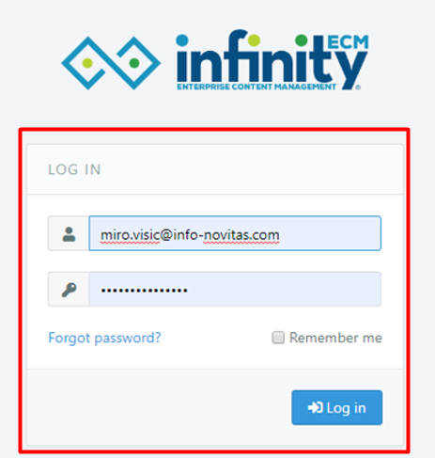

Figure 2: User login over base

**Forgotten password** - If the user forgets the login information, on web application form he should choose the "Forgotten Password?" option.

When the user clicks on the link, a web form for reverting will be displayed.

**The Remember Me** option - used to remember user login.

If the user comes back to the login page at a certain time and the application has not expired, then the user is automatically redirected to the web application.

## **1.2. Login with Azure AD**

In order to login with Azure AD you should have an active 365 Office account.

You should enter the *username* and *password.*

You can sign in to the application only with correct information. In the case of incorrect data information, a login error is displayed.

By clicking**Login with Azure AD,**the user is redirected to the 365 Office account to log in.

After successful login the user is redirected to where the Active Directory user account must be linked to the account.

On every new login user should normally login via the Active Directory account.

If the user is already logged, he is automatically redirected to platform.

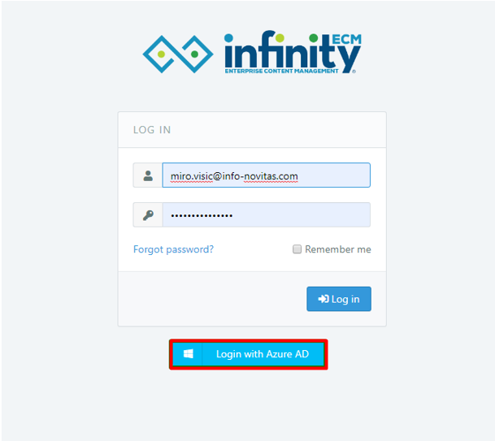

Figure 3: User login with the Azure AD

# **2. Main control panel**

After a successful login, the main control panel is displayed. In the right corner, there is a User Menu so you can access to Documentation, Support or System administration, on the left you can find a sidebar with all subsystems, in the header you can find a toolbar with notifications, chat, search etc., and on the background, there is Dashboard with available widgets.

## **2.1. User Menu**

First, we will explain the user menu in the right corner of the platform.

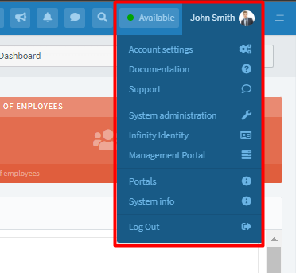

Figure 4: User Menu

In the user menu you can find options:

* **My profile -** link on user activity stream and involved projects.
* **Account settings -** link on user profile edit (change personal data, contacts or localization), change password, set notifications for enabled subsystems etc.
* **Documentation -** link on complete User's Guide where you can find all answers about system functionalities.
* **Support -** once you are signed in to the system, in the right corner of the system under the user menu you'll find Support where you can report bugs etc.
* **System administration -** visible to users who are administrators. Only system administrator can create a user and determine which subsystems according to chosen permission schema he can see.
* **Log out -** logged out option.

## **2.2. Toolbar**

Options available on the toolbar (Figure 5):

1. Toggle sidebar
2. Quick Create
3. Email tracking
4. Change language
5. Assigned tasks overview
6. Notifications overview
7. Chat
8. Search

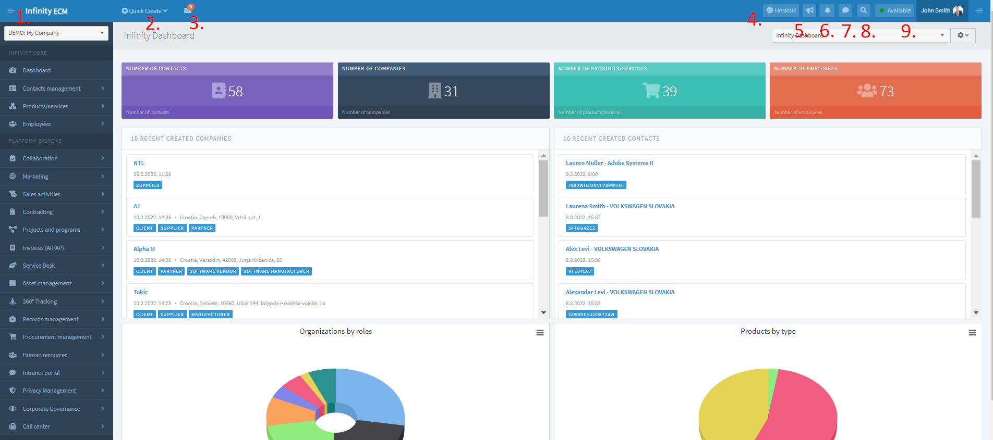

Figure 5: Toolbar

## **2.3. Sidebar (available subsystems)**

Available subsystems are displayed to the user (depending on user permissions).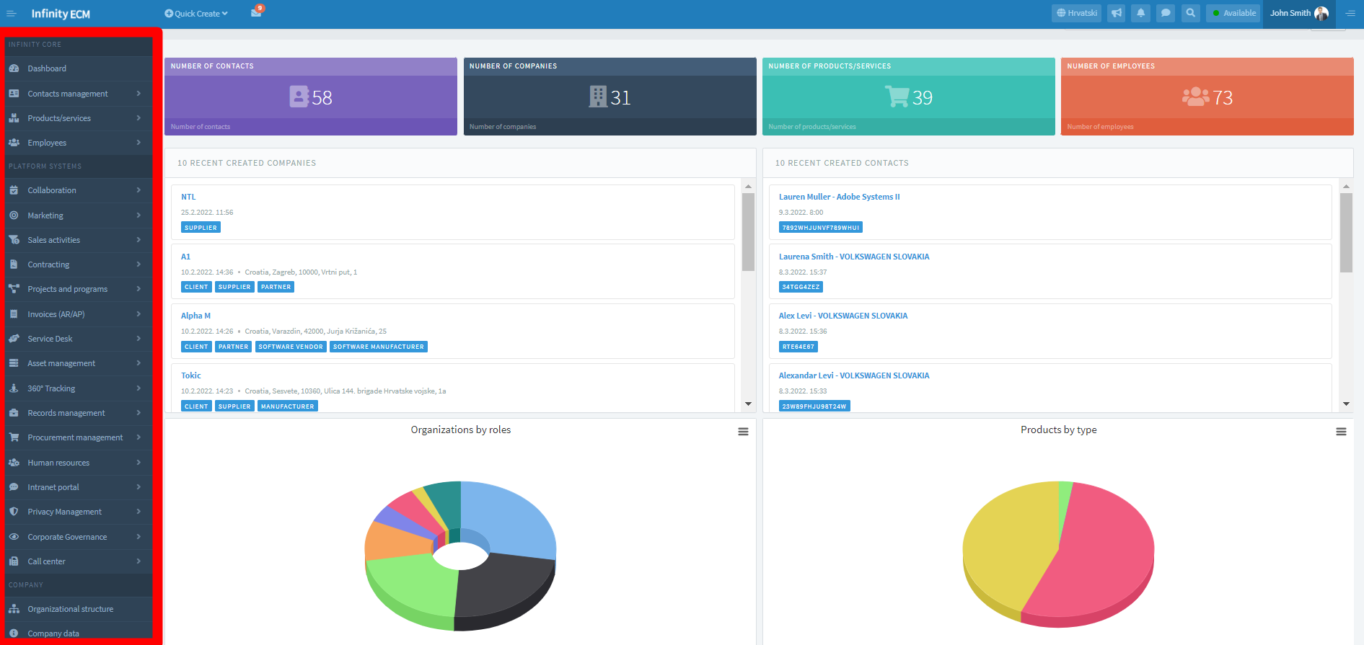

Figure 6: Available subsystems at the Sidebar

The user will be able to see subsystems **only if the administrator set:**

1. work schedule on form for creating the user (if the work schedule is not set, the warning notification will appear after user login). In order for the administrator to choose work schedule, work schedule should previously be created on **System administration à Sidebar: Users Management à Organization Units & Work types.** The work schedule is obligatory field on the form for user create and it can be changed on user update or user profile in administration.
2. user rights/permissions on form for creating the user (permission schema is chosen from the dropdown). **System administration à User profile à Security à User permissions.**

***For creating organization units and work schedule read more in chapter 4.2.***

***For setting user rights and notifications read more in chapter 3.***

### **2.3.1. Table overview settings**

In this section, we will explain options on the table overviews. The concept of all table overviews in the system is similar for all modules. ***Table overview is accessed through the sidebar menu.***

Slika na kojoj se prikazuje stol

Opis je automatski generiran

Figure 7: Table overview - settings

The main options on the table overview you shod know are:

1. **Add option** - link on creating a new entity (eg new contract).
2. **Export to excel option** - the user can download a table overview in excel format.
3. **Column filter** - selecting the filter option it opens the filtering line.
4. **Date filter** - filter is set from the first day of the month to today. In case the filter is turned off, all items will show in the table.
5. **Items per page** - change the number of items per page.
6. **Refresh** - table refresh.
7. **Grid filter reset** - reset filtering.
8. **Save table settings (closed lock icon)** - save newly added columns, new column sort etc.
9. **Delete all table settings (open lock icon)** - delete all table changes.
10. **Context menu** - available options: profile, edit, delete item.
11. **Sorting columns** - for sorting columns you should drag and drop columns to the desired place in the table.

**For saving column layout you must select the lock icon at the bottom of the table.**

### **Entity profile**

In the previous section we explained table overview settings. Through the table overview, user comes on entity profile. Now we will explain profile structure.

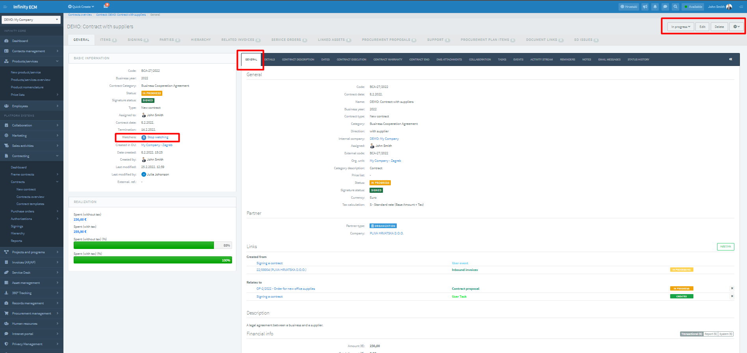

Figure 8: Entity profile

The left part of the web form contains basic information about the entity.

The right part of the web form consists of tabs characteristic for a particular profile.

In the header there are basic options like an update, delete or status change + other options characteristic for a particular profile.

**Start watching option** - when enabling notifications for a module in system administration, you also need to click on start watching option on entity profile so you could start receiving notification for individual modules.

***For setting notifications read more in chapter 3.2.***

# **3. Administration - user rights and notifications**

In order to edit user Rights and Notifications administrator should open the User menu in the right corner of the system and go to user profile like is described below:

1. **User menu à System administration à double click on the user name on the widget *Last logged users,*** or
2. open internal users overview in the sidebar and choose Profile option from the context menu on the Internal user overview. **System administration à Users à Internal users overview à Profile.**

Slika na kojoj se prikazuje stol

Opis je automatski generiran

Figure 9: Guide to user profile

## **3.1. User permissions**

*If you have followed the previous steps, you are on the user profile. To update user rights, you need to go to the tab* ***Security.***

Slika na kojoj se prikazuje tekst

Opis je automatski generiran

Figure 10: Security tab on user profile in administration

On the Security tab, the administration can:

* Change user password
* **Update user permissions -** when updating permissions you have **two options:**

1. If the checkbox **Use custom settings**is not selected, then you can **choose Permission schema** from the dropdown. *(Figure 11).* Of course, in order to choose permission schema, you should previously create it on Template overview (Permission schema). **Creating permission schema is done over System administration à Sidebar: Security à Permission schemes à Templates overview à Add.**
2. **User custom settings checkbox is selected (select & save) -** two new tabs will appear: Platform systems and Roles. Now you can add platforms and edit roles *(Figure 12 & 13).*

**OPTION 1:** checkbox **Use custom settings**is not selected *(Figure 11)*:

If the checkbox **Use custom settings is not selected**, then user from Permission scheme dropdown chooses scheme which is previously created on Template overview (permission schemes). **System administration à Security à Permission scheme à Templates overview.**

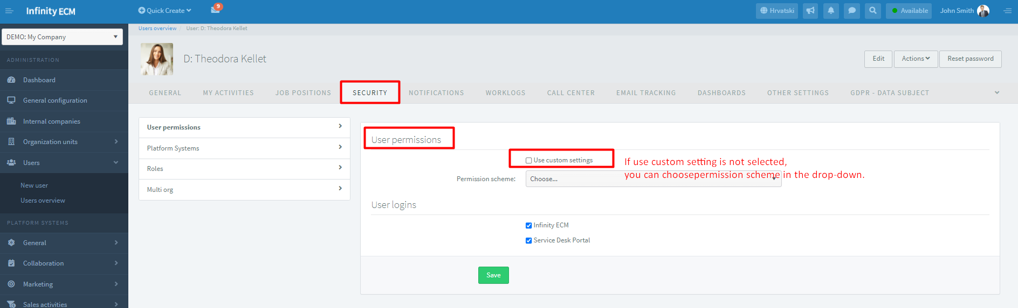

Figure 11: Choose Permission schema from the dropdown

**OPTION 2: User custom settings** checkbox is selected *(Figure 12):*

User custom settings checkbox is selected (select & save checkbox) and two new tabs are displayed.

If the administrator on User permissions choose the checkbox **Use custom settings**, then two new tabs will be displayed: Platform systems and Roles. In these tabs, he can choose which platforms and roles he wants to see.

Slika na kojoj se prikazuje tekst

Opis je automatski generiran

Figure 12: Checkbox Use custom settings is selected

**Platform systems tab:**

* enable all modules that you want to see (system administrator enables for other employees) and then in tab Roles you select all wanted roles for enabled modules.

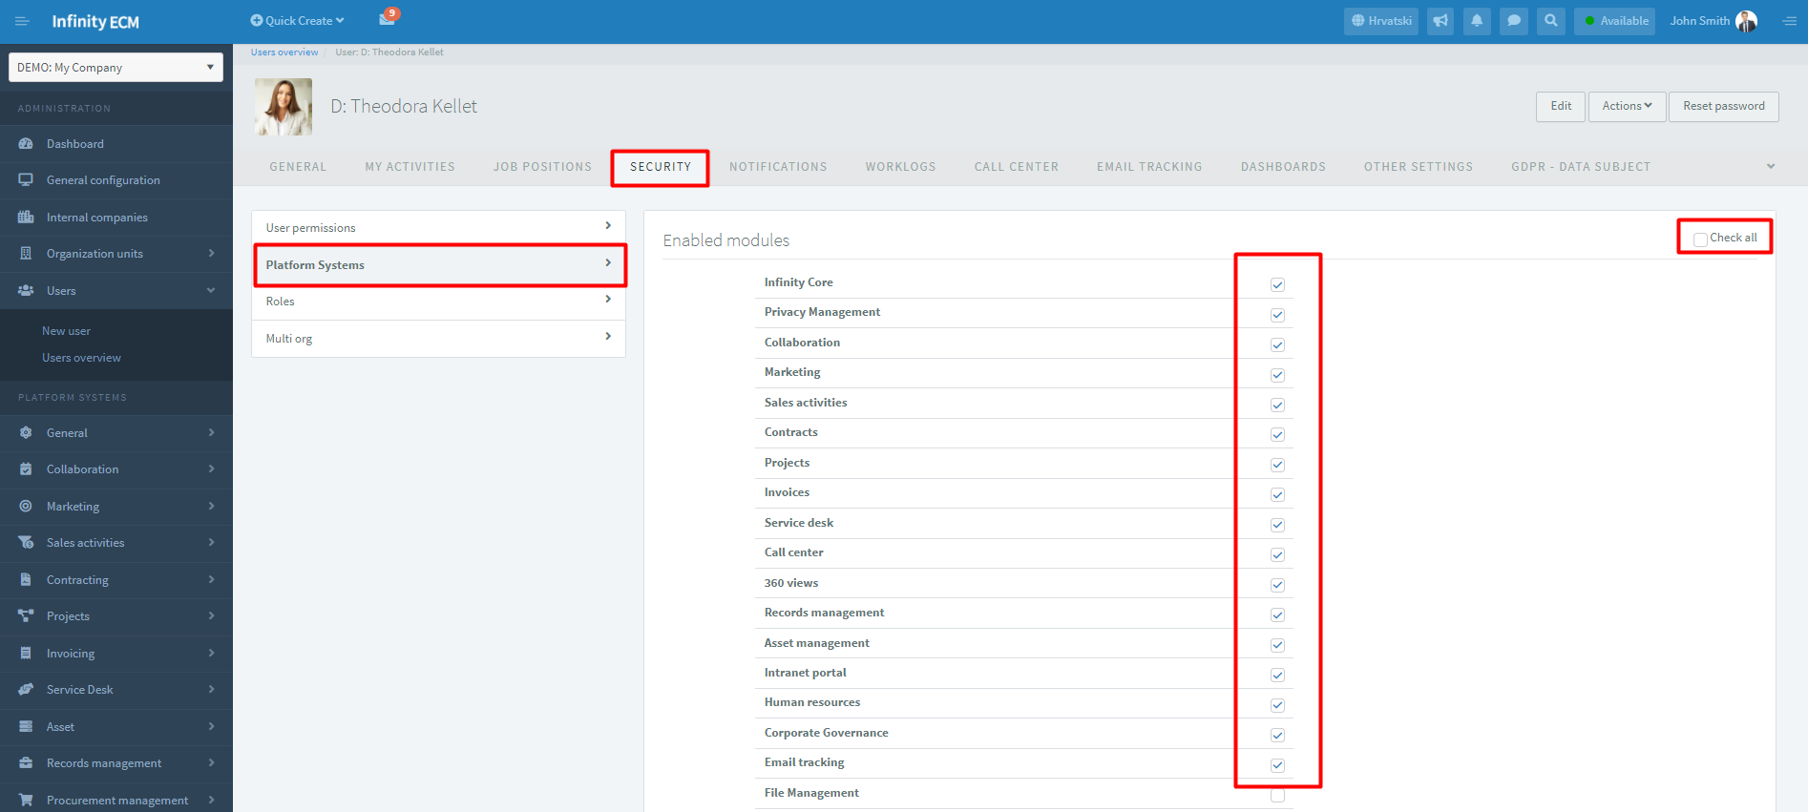

Figure 13: Choose modules on Platform system tab

**Roles tab *(Figure 14):***

* when choosing roles (creating, updating, deleting etc.), you can also choose Row level security (RLS) for each overview.
* in this way each employee will see modules which he supposed to see and have roles in line with his position.
* also, row security level (RLS) enables that you see items: only yours, in the same org. unit, subordinated or all items.

**IMPORT OPTION**: through this option you can also import permission schema or role group. For import, previously you need to create permission schema & role group. Read more in chapters 3.1.1. and 3.1.2.

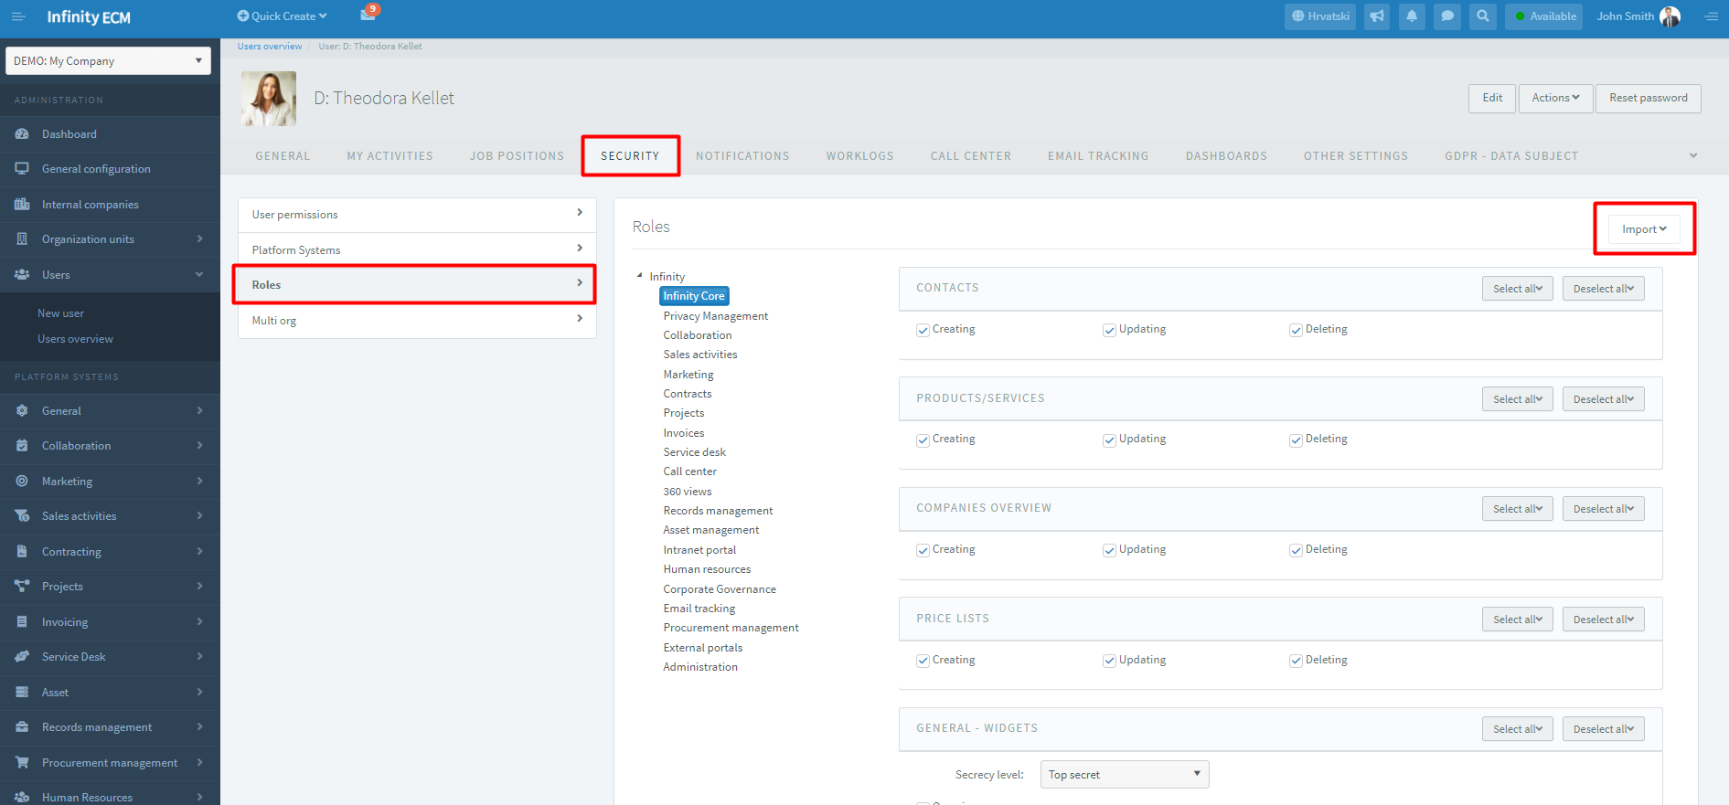

Figure 14: Choose roles for enabled modules

### **3.1.1. Creating permission schema**

We have already mentioned that for choosing permission schema on the user profile, administrator previously needs to create permission schema **over System administration à Sidebar: Security à Permission schemes à Templates overview à Add.**

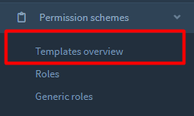

Figure 15: Administration sidebar: permission schema overview

Steps on creating permission scheme:

1. **Choose an Add option to create permission scheme**
2. **choose Enable modules option from the context menu and add modules on a created scheme**
3. **Edit roles on enabled modules**

When you are done, you can choose the permission scheme **on user profile in administration or on form for creating a user.** Eg: if you create a **scheme for module Marketing** than you can create a role group and join the created module. ***About creating a role group read more in chapter 3.1.2.***

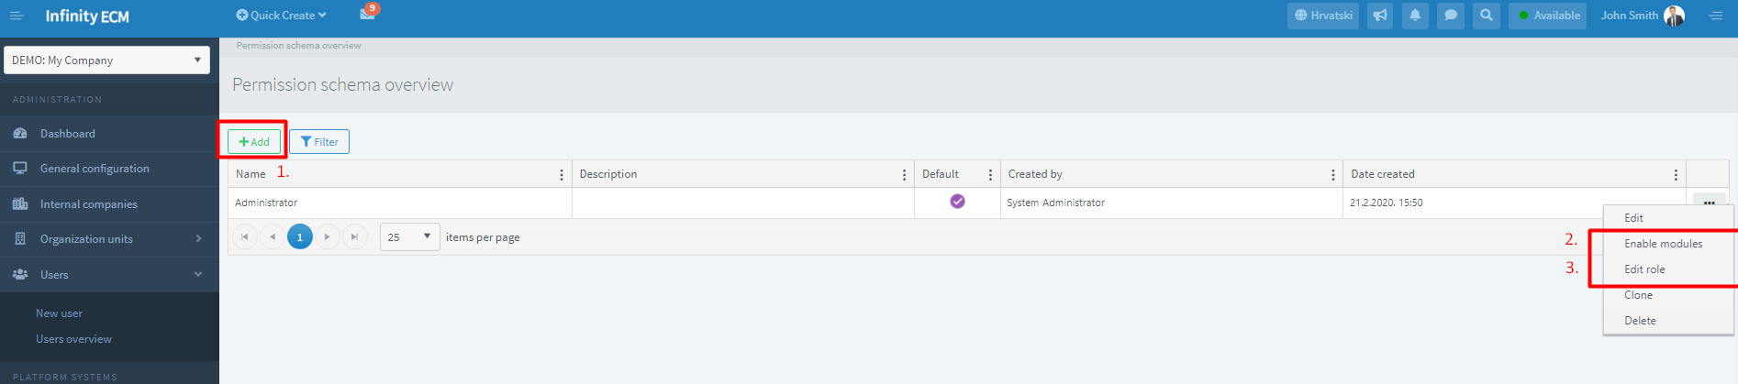

Figure 16: Creating permission scheme: enabling modules and edit roles

### **3.1.2. Creating role group**

Also, for choosing role group on user profile administrator previously need to create role **group over System administration à Sidebar: Security à Permission schemes à Roles à Add.**

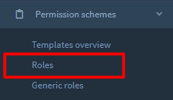

Figure 17: Administration sidebar: creating role group

After creating a role group, you can manage roles. When you are done, you can choose a role on user profile in administration for chosen permission scheme.

Slika na kojoj se prikazuje tekst

Opis je automatski generiran

Figure 18: Creating and managing role group

## **3.2. User notifications**

Two important steps you need to do if you want to receive notifications:

1. **Set notifications for wanted module (choose Intern/Email)**

Slika na kojoj se prikazuje tekst

Opis je automatski generiran

Figure 19: Enabling notifications (internal/email) for modules

1. **On entity profile in the user part, auser should click on option Start watching.**

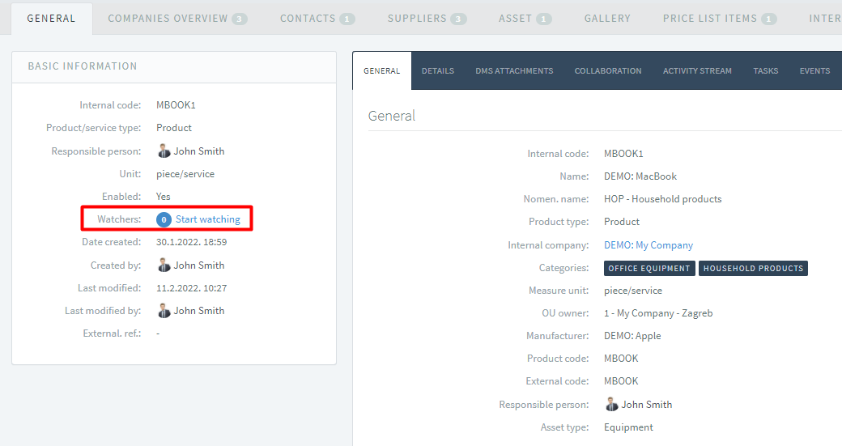

Figure 20: Start watching option on entity profile

There are two ways of setting up notifications:

1. **over Account settings (user access). *User menu à* Account settings à Notifications (for all employees)**
2. **over System administration on the user profile (for administrators only).** **User menu à System administration à go to user profile over widget or over Internal user overview in the administrator sidebar à Profile à Notifications.**

Unlike the users, the administrator has an additional option to configure the notification – the option *Import notification group. (Figure 19). For notification group import user should previously create notification groups.*

***For creating notification group read more in chapter 3.2.1.***

Once the user set the notifications and clicks on the option **start watching**, the notifications will start arriving.

Slika na kojoj se prikazuje tekst

Opis je automatski generiran

Figure 21: Notifications overview

### **3.2.1. Creating notification schemes**

We have already mentioned that for choosing notification schema on form for user create you previously need to create notification schema **over System administration à Sidebar: Security à Permission schemes à Templates overview à Add.**

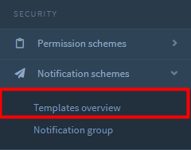

Figure 22: Administration sidebar: creating permission scheme

After creating notification scheme you can choose the notification scheme **on form for creating user.**

Slika na kojoj se prikazuje tekst

Opis je automatski generiran

Figure 23: Creating notification scheme

### **3.2.2. Creating notification groups**

Also, for choosing notification on user profile you previously need to create role **group over System administration à Sidebar: Security à Notification schemes à Notification group à Add.**

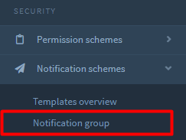

Figure 24: Administration sidebar: creating notification group

After creating notification group you can manage notifications. When you are done, you can choose notification group for specific module on **user profile in administration. Eg: if notification group is created for module Marketing, when administrator is on user profile on Notifications situated on module Marketing – from Import option he can choose previously created notification group.**

Slika na kojoj se prikazuje tekst

Opis je automatski generiran

Figure 25: Creating and managing notification group

# **4. Administration sidebar**

The administration is available only to the users who are administrators. In administration sidebar you can create code books and set other settings like creating organization units and internal users, create necessary plugins, adding email boxes, edit permissions and notification schemes, etc.

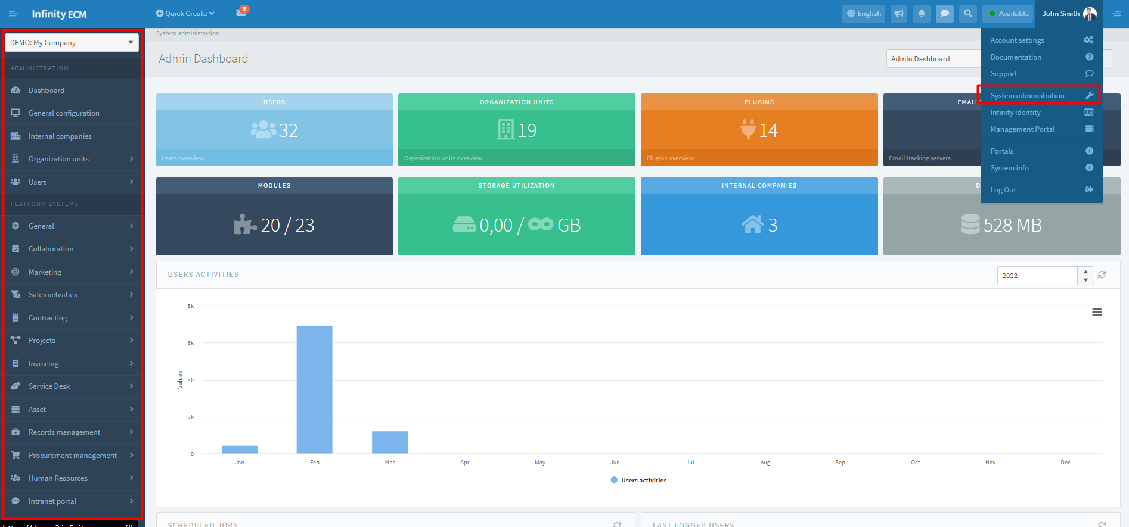

Figure 26: System administration

## **4.1. Creating code books**

Code books define fields that appear in the user area in the drop-down menu. Code books are divided by subsystems. You can set code books specifically for each of the module. For example, if creating a contract in the user part and it opens empty drop-down, administrator probably needs to create some codebooks. Administrator should go to **System administration à module Contracts à Code books à Add. In order for the user to see code books in user part, code books need to be enabled on form for creating *(Figure 27).***

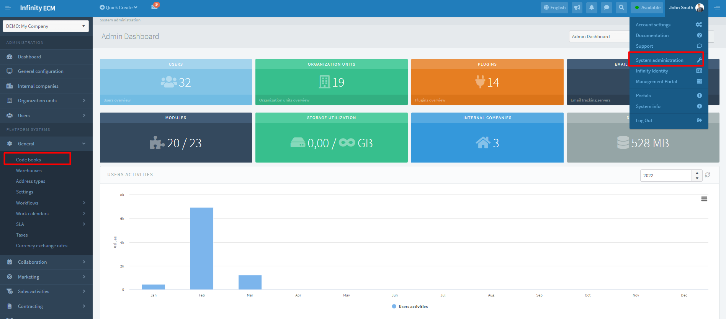

Figure 27: Code books in system administration

## **4.2. Creating organizational units and work types (basis for user create)**

One of the first steps in the system is creating users. In order to create a user, administrator needs to create organization units and work types so he could choose these two fields on user create.

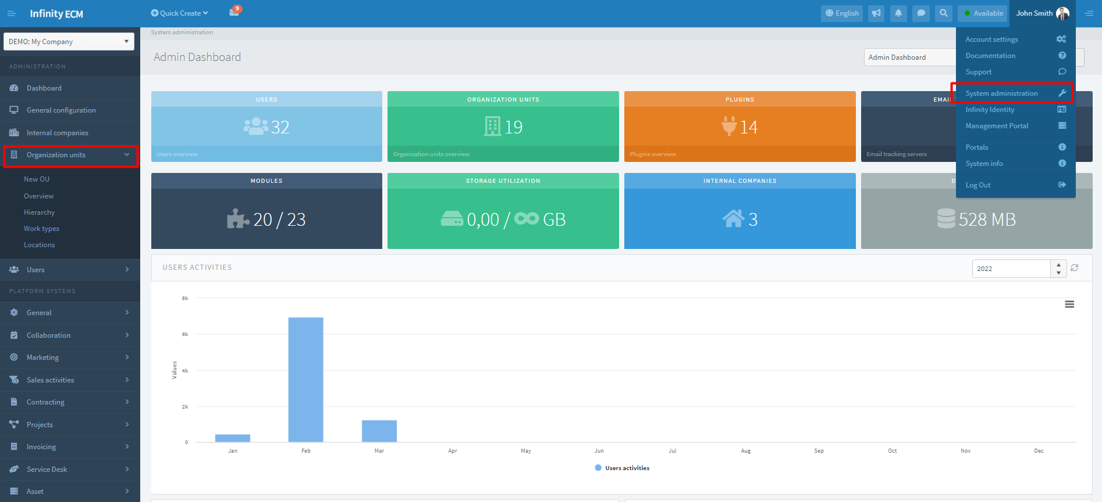

Figure 28: Organization units in system administration

* Organization unit create is done over **User menu** à **System administration** à **Users management in the sidebar** à **Organization units** à **Overview** à **Add.**
* Work type create is done **over User menu** *à* ***System administration*** *à***Users management in the sidebar** à **Work types** à **Add.**

## **4.3. Creating internal user**

Now that organization units and work types are created, you can create a user. New internal user creates is done over **User menu à System administration à Users à Internal users overview à Add.**

***For select permission and notification scheme on form for creating read more in chapter 3.1.1. & 3.2.1.***

***For all fields description on form for user create visit complete User’s Guide under the Documentation section.***

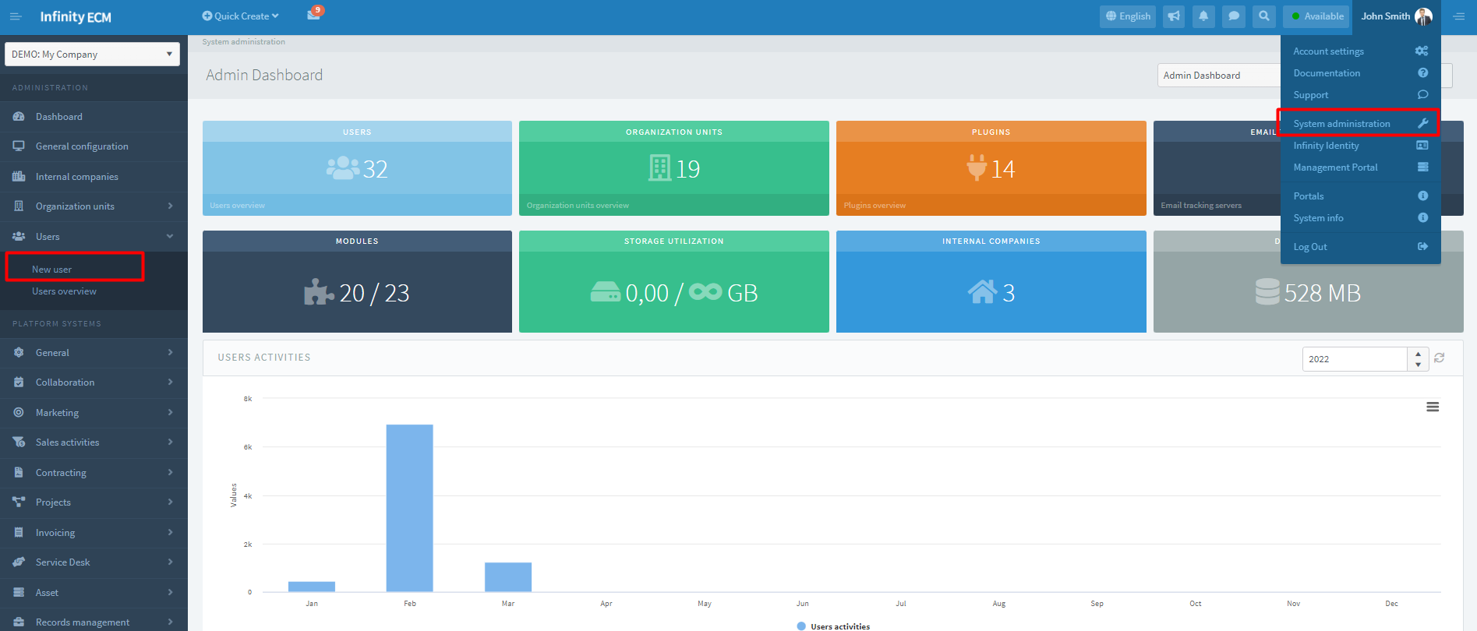

Figure 29: Creating users in system administration

## **4.4. Dashboard Management**

Basic dashboards for each module are initially set. Creating new dashboards and adding widgets is done over **User menu à Sidebar: User interface à Dashboard Management à Dashboard overviewàAdd.**

For adding widgets on created Dashboard, the administrator should choose option **Profile** in the context menu on the **Dashboard overview.**

## **4.5. Email mailboxes**

Adding email mailboxes is done over **User menu à Sidebar: Mails à Email tracking à SettingsàAdd.**

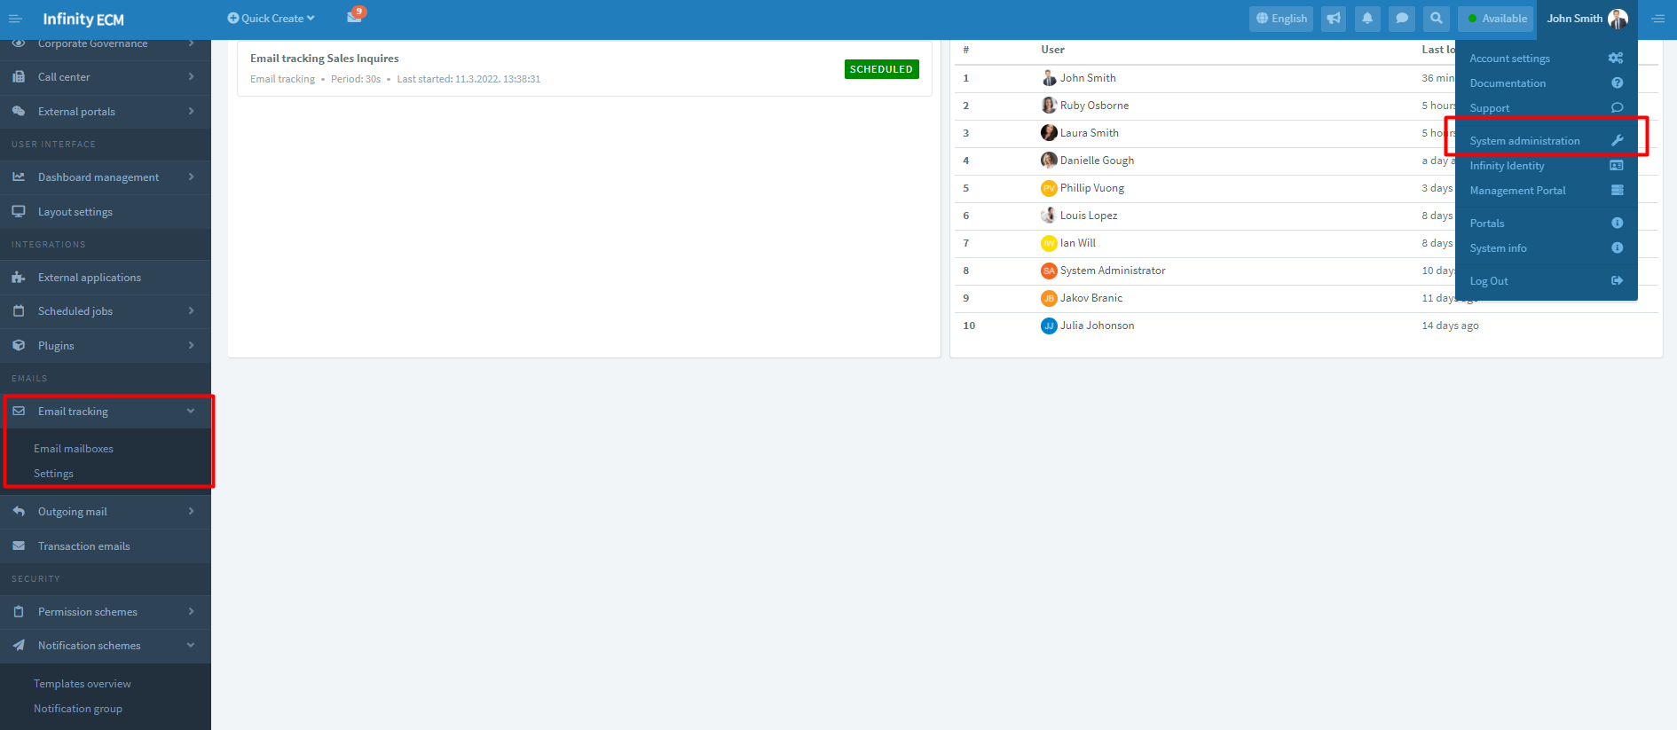

Figure 30: Email mailboxes in system administration

If created email tracking server is enabled, the scheduled task will be created. When email tracking server is created, tracking does not start automatically, it is necessary to start tracking on **Administrator sidebar:** **Mails à Scheduled jobs.**

***You can read more about managing the scheduled jobs in chapter 4.7. Scheduled jobs.***

If email tracking server is not enabled on form for creating, the scheduled task won’t be created. You need to create a manually scheduled new task **on Scheduled jobs** and enter the email tracking server ID. ID you can find on email tracking server profile.

After the successful creation of the scheduled task, it is necessary to **start the task**. Platform will record a new task on a web service and run periodic mailbox tracking.

**DEFINING AGENTS ON EMAIL TRACKING PROFILE**

In order for users to see an email tracking server in the user account, the administrator needs to select a list of users who can see the email tracking server in the email tracking server profile. This is done through the tab AGENTS on the Email tracking server profile.

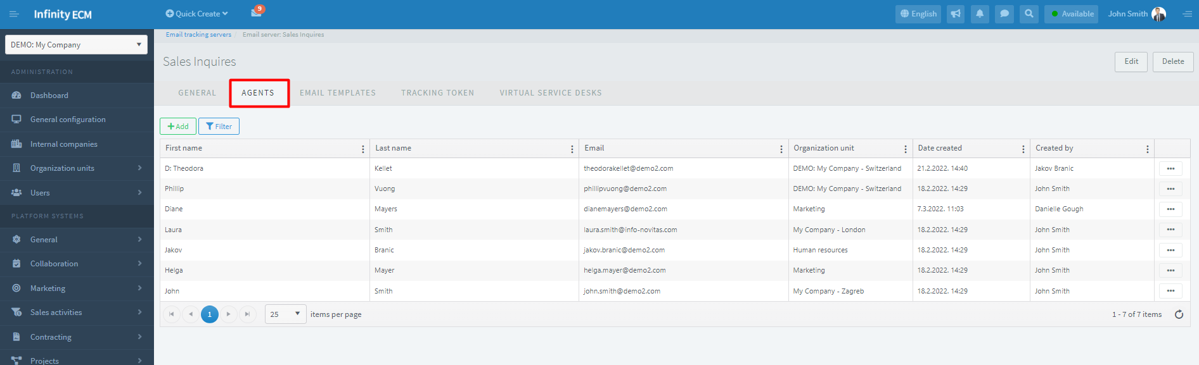

Figure 31: Setting agents

**SETTINGS FOR MONITORING ON EMAIL TRACKING PROFILE**

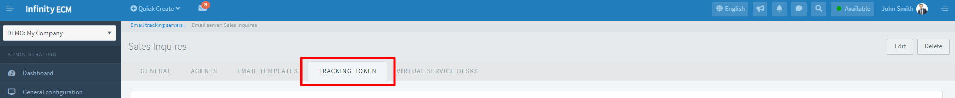

On the email tracking server profile, the administrator can define email tracking token settings. Tokens are generated for incoming and outgoing emails and added to the email message subject, which significantly improves the mail pairing process.

In each email token, unless otherwise is defined, to the end of the token is added a counter to make each token unique and avoid duplicates *(Figure 32).*

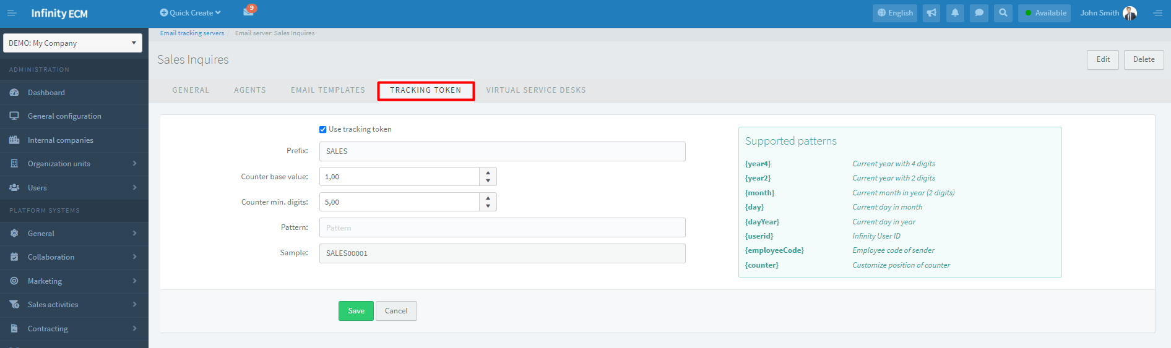

Figure 32: Configure tracking token

|  |  |
| --- | --- |
| Field Name | Description |
| Use tracking token | If this option is enabled, the web service will use the pairing of the email message through the tracking token. |
| Prefix | The prefix that will be added to the generated token.. It is desirable to use large letters without spaces. |
| Counter base value | Initial counter value (eg if you don’t want the counter start from 0) |
| Counter min. digits | The number of leading zeroes for the counter. |
| Pattern | Counter template. On the right are supported templates that can be added to generate a counter template. |

Table 1: Configure tracking token

Once the email tracking token is enabled, the web service will start generating badges for incoming and outgoing mail.

***How to create labels, set option Auto recognize contact, or create user email signature check in complete User’s Guide on Documentation section.***

Once the mailbox is created, you can find it in the user part in Toolbar.

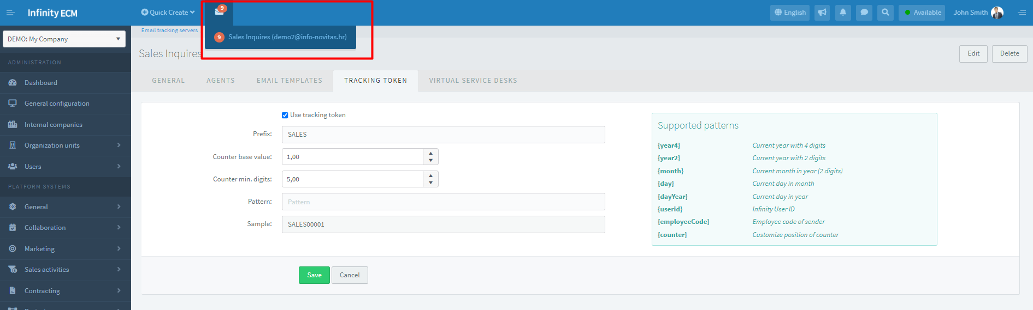

Figure 33: Created email tracking server (mailbox)

## **4.6. Outgoing mail (setting email notifications)**

To handle email notifications system, you need to define the outgoing mail server settings in the administration. **User menu à System administration à Sidebar: Mails à Outgoing mail.**

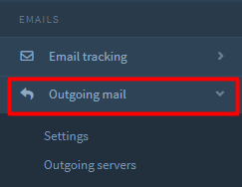

Figure 34: System administration: Outgoing mail

**In the outgoing mail settings, you can choose three different behaviors of the system (Figure 32):**

* **Disabled** - Outgoing mail is not sent from platform (sending email notifications is blocked)
* **SMTP server** - sending email notification and the message is enabled with the selection of outgoing (SMTP) email servers
* **External service** - sending email notification and message is enabled by selecting plug-in through which to send outgoing mail.

**User menu à System administration à Sidebar: Mails à Outgoing mailàSettings.**

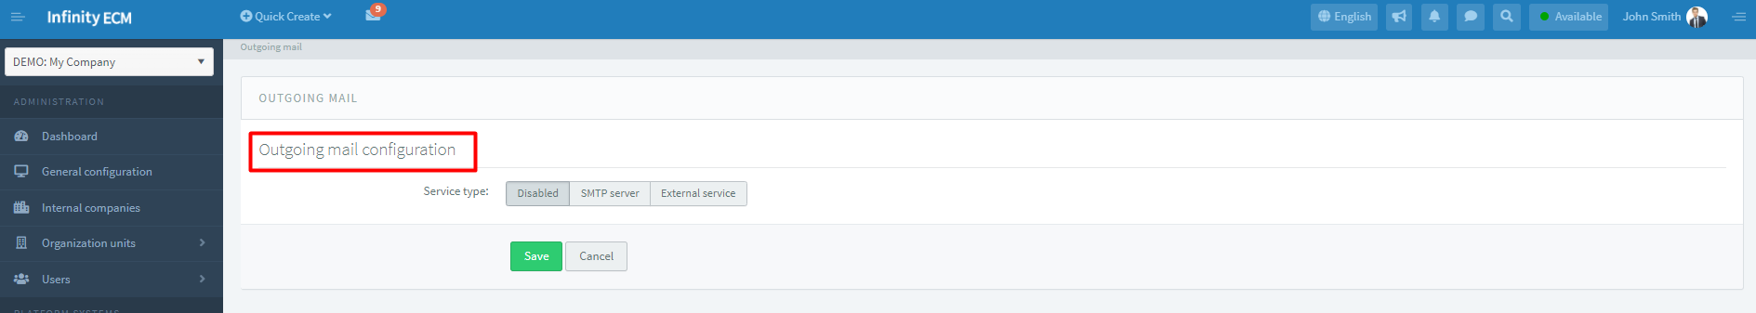

Figure 35: Outgoing mail configuration

For adding Outgoing server, the administrator should go on **Outgoing servers** overview and **choose the option Add in the header. System administration à Sidebar: Mails à Outgoing mailà Outgoing servers.**

For specific processes, you specify servers that will send email messages (eg. GDPR injuries, reminders, etc.).

***For fields description on form for creating Outgoing server visit* complete User’s Guide under the Documentation part.**

## **4.7. Scheduled jobs**

Platform supports execution of background tasks that are periodically executed. **System administration à Sidebar: Mails à Scheduled jobs.**

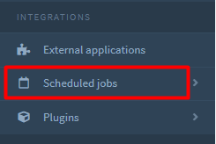

Figure 36: System administration: Scheduled jobs

The following types of scheduled tasks are currently supported (Table 2):

|  |  |  |
| --- | --- | --- |
| Field name | Description | |
| EMAIL TRACKING JOB | | A background task that periodically checks incoming and outgoing mail in an email mailbox and connects emails with entities in (companies, contacts, leads, users, GDPR respondents). |
| REMINDERS JOB | | A task that allows sending email or SMS reminders. Defining general reminders can be done in the Core submenu sidebar, while on offers, contracts you can define reminders that are related to the items. |
| PERIODIC INVOICE ISSUE JOB | | The task that serves to issue and send recurring outgoing accounts. Users who use the *Accounts subsystem* have the ability to define recurring accounts. Task sends outbound accounts to clients according to repetition settings in a recurring account. |
| GDPR CONSENT REVOKING JOB | | The task that is periodically executed and checks GDPR consents and for the expired GDPR consents sets status to expire. |
| SET NOT PAID INVOICES JOB | | The task that verifies the issued outbound and outbound invoices issued by the expiration date - sets their status to *Unpaid.* |
| GDPR ACQUIRE CONSENTS JOB | | The task is periodically executed and sent to a certain list of respondents (provided there is a legitimate basis for data collection) via which the respondents can give access to a specific purpose of processing through the GDPR Portal. |
| ASSET NETWORK DISCOVERY JOB | | The task is periodically executed and over "network discovery" plugin detects and records new assets (eg. Open Audit). |

Table 2: Supported scheduled tasks

The scheduled tasks are periodically executed on web service. Tasks may be in the following statuses:

* **Scheduled** - the task is created, it needs to be started
* **Running** - web service has scheduled the task and is periodically performed.
* **Stopped** - is set when the administrator stops the task.
* **Failed** - is set when three consecutive errors occur during task execution. The task was terminated due to a configuration or web service error.

For adding Scheduled job, the administrator should go on Scheduled jobs overview and choose the option Add in the header. **Administration à Sidebar: Scheduled jobs à Overview.**

***Field description on Scheduled job adding form* check-in complete User’s Guide on Documentation part.**

## **4.8. Plugins**

The ability to expand system functionality through the Infinity ECM plug-in has been implemented and the plan is to support the ability to develop plugins for the Infinity ECM. The Administrator can access to Plugins over **System administration à Sidebar: Integrations.**

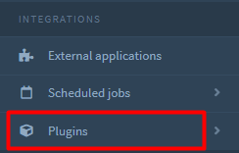

Figure 37: System administration - Plugins

Through platform are currently supported integration for:

* **Call Center Service** - supports initiating calls for registered phone numbers
* **Cloud Drive Service** - Supports upload/download/manage files on external file services and DMS (eg. Google Drive, Azure Storage, Alfresco)
* **Mass Email Service** - Supports bulk email messaging through a marketing campaign
* **Mass Fax Service** - supports mass mailing of fax messages through a marketing campaign
* **Mass SMS Service** - Supports bulk SMS sending through a marketing campaign
* **Outgoing Email Service** - Supports sending transactional email messages
* **Currency Exchange Rate Service** - supports downloading and processing of exchange rates
* **Asset Discovery Service** - Supports Calling NDIS System and Automatic Device Discovery on Network Infrastructure (e.g. Open Audit)
* **SMS Provider** - supports sending SMS messages (e.g. InfoBip)
* **e-Invoice Provider** (in implementation) - the plan is to enable sending an e-Account. For each integration point, additions within the have been implemented, which are specifically activated for each business. The list of active plugins for the company is in administration and is visible through the Plugins menu item on **System administration à Sidebar: Integrations à Plugins.**

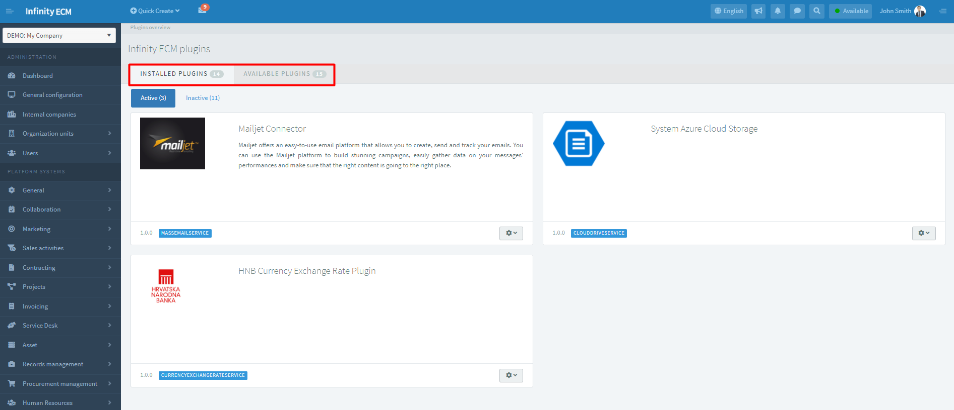

Figure 38: System administration: Plugins overview

When the system is delivered, the plugins are not configured, and the administrator must provide the plugins to the administration pages for properly work and necessary information’s.

Each plugin can be temporarily disabled to not be displayed in the selections when starting specific processes that require them. Except for managing plugins through the Options, the administrator can define and select default plugins for specific business processes (e.g., the default plugin for downloading courses, initiating calls, etc.)

**FIGURE CONTENT**

Figure 1: Dashboard – link on complete User's Guide 3

Figure 2: User login over base 4

Figure 3: User login with the Azure AD 5

Figure 4: User Menu 6

Figure 5: Toolbar 7

Figure 6: Available subsystems at the Sidebar 8

Figure 7: Table overview - settings 9

Figure 8: Entity profile 10

Figure 9: Guide to user profile 11

Figure 10: Security tab on user profile in administration 12

Figure 11: Choose Permission schema from the dropdown 13

Figure 12: Checkbox Use custom settings is selected 13

Figure 13: Choose modules on Platform system tab 14

Figure 14: Choose roles for enabled modules 15

Figure 15: Administration sidebar: permission schema overview 16

Figure 16: Creating permission scheme: enabling modules and edit roles 16

Figure 17: Administration sidebar: creating role group 17

Figure 18: Creating and managing role group 17

Figure 19: Enabling notifications (internal/email) for modules 18

Figure 20: Start watching option on entity profile 18

Figure 21: Notifications overview 19

Figure 22: Administration sidebar: creating permission scheme 20

Figure 23: Creating notification scheme 20

Figure 24: Administration sidebar: creating notification group 20

Figure 25: Creating and managing notification group 21

Figure 26: System administration 21

Figure 27: Code books in system administration 22

Figure 28: Organization units in system administration 22

Figure 29: Creating users in system administration 23

Figure 30: Email mailboxes in system administration 24

Figure 31: Setting agents 25

Figure 32: Configure tracking token 25

Figure 33: Created email tracking server (mailbox) 26

Figure 34: System administration: Outgoing mail 27

Figure 35: Outgoing mail configuration 27

Figure 36: System administration: Scheduled jobs 27

Figure 37: System administration - Plugins 29

Figure 38: System administration: Plugins overview 30

**TABLE CONTENT**

Table 1: Configure tracking token 26

Table 2: Supported scheduled tasks 28